**Linked list (Forward & Backward) and binary tree**

**Part 1 : Forward and backward linked list**

Exercise 1 : Create forward and backward linked list

Code:

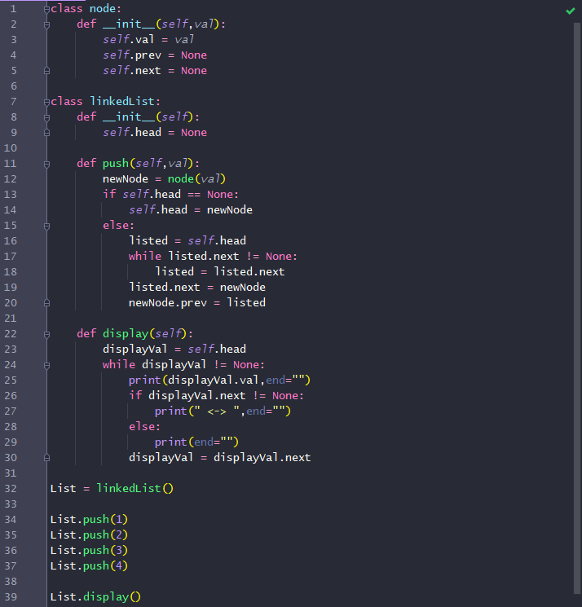

Result :



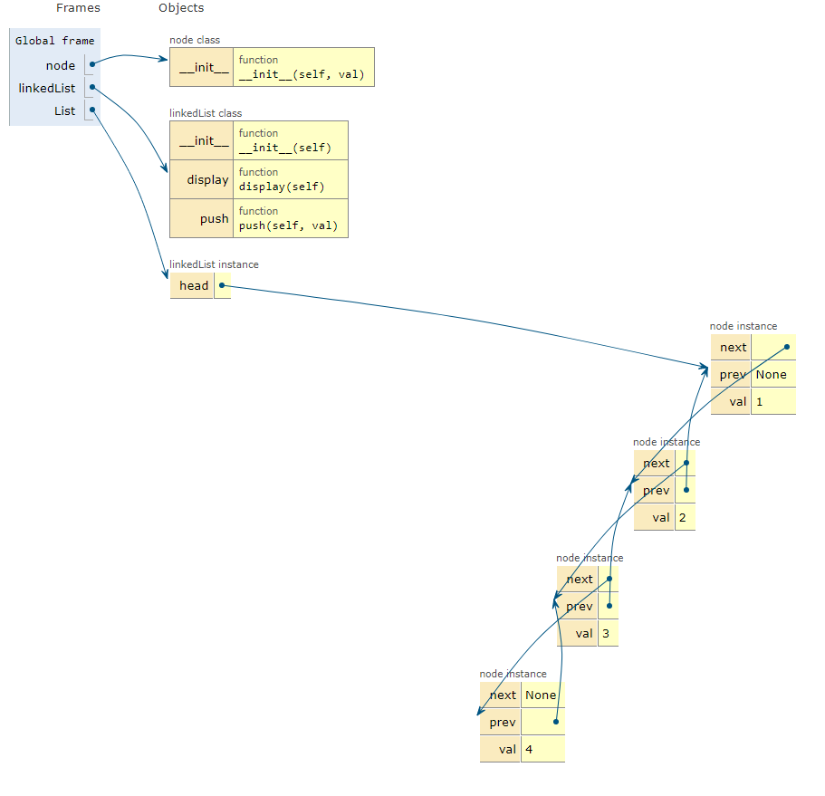

**Part 2 : Binary tree**

Code :

Class and insert node function

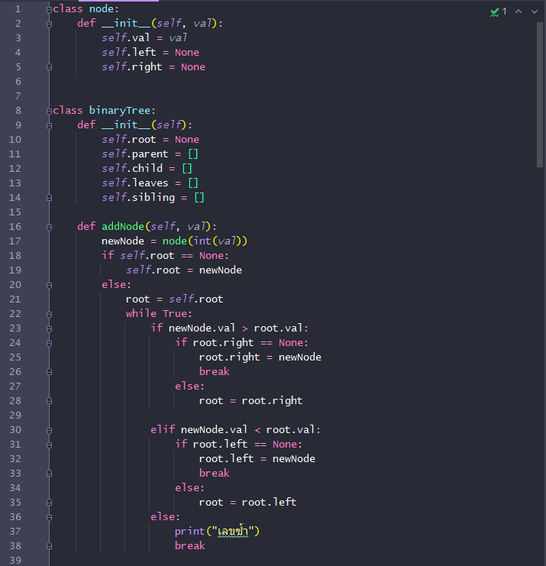

Delete node function

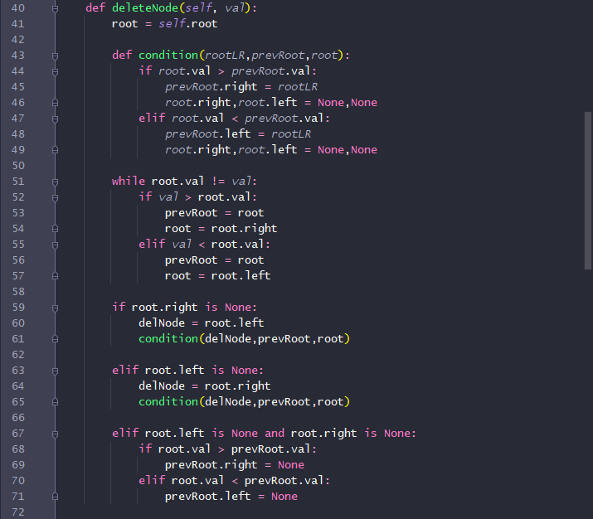

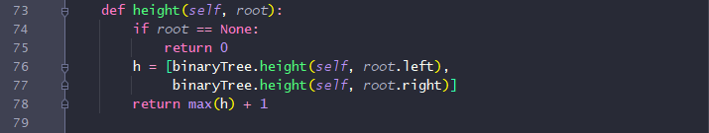Find height of binary tree function

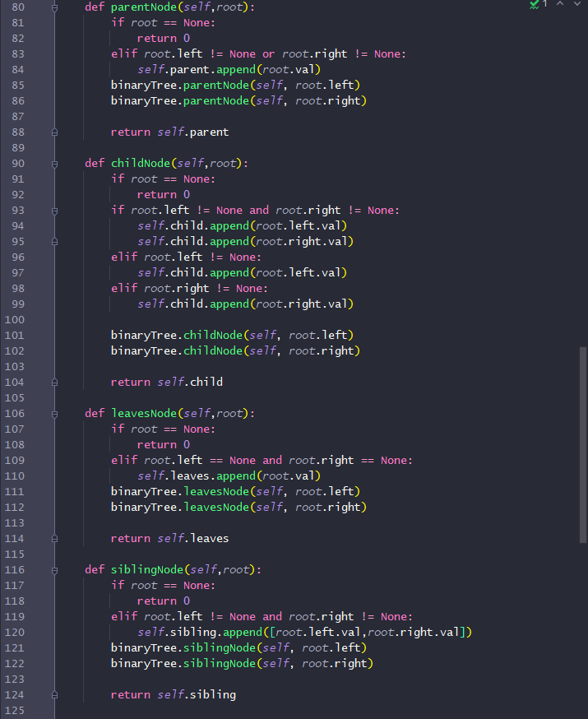 Find parent, child, leaves, sibling node of binary tree function

Display function 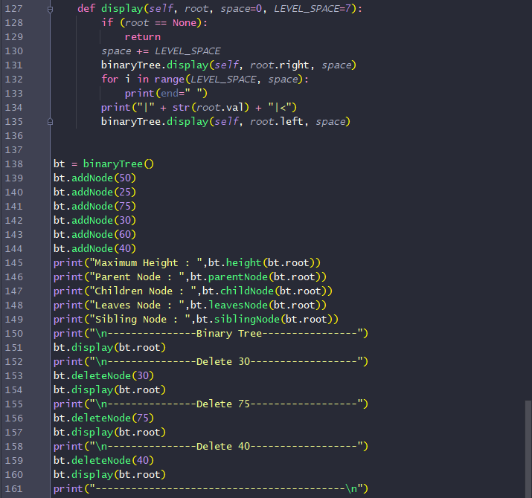

Result :

Exercise 2.1 : Create binary tree

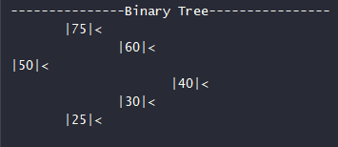

Exercise 2.1 : Remove value in binary tree

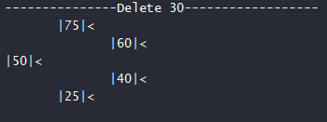

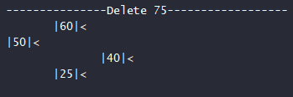

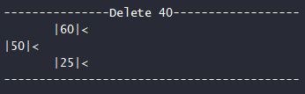

Ex 2.3 : Theory part (coding is needed)

